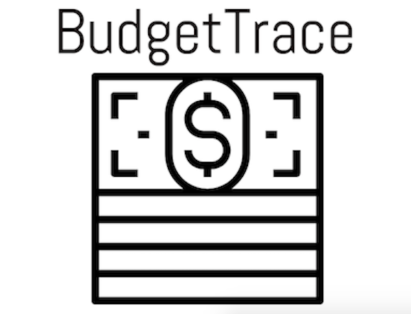

USER MANUAL

Marian Vladoi, Matthew Frank, Mikail Lychagin,
Nick Pappas, Hasson Qayum

Product Name: Budget Trace

Team Name: Coding Conduct

Release Version: V 1.0

Latest Release Date: 07/25/2017

Author’s Note: I’m writing this document under the assumption that you are reading this off our github; if you found this somewhere else please refer to that hyper-link for documentation and current version.

Budget Trace is a financial Web Application. It is a tool to help you to track and visualize your spending habits. As a team we decided that we would locally host a server to develop our product on rather than pay to host an actual website. This is inconvenient from a distribution perspective, but convenient for us as developers. If it were to be hosted online the application would run the same.

Downloading Essential Software & Source Code

If you haven’t already you’re going to want to clone/download our repository from github.

You now have the working build in a folder appropriately named plus our previous versions, testing, and SCRUM documentation as well. Remember the working build folder, we will need it.

Whichever operating system you are running on should be fine. This product was designed and tested on Windows, Linux, and Mac computers.
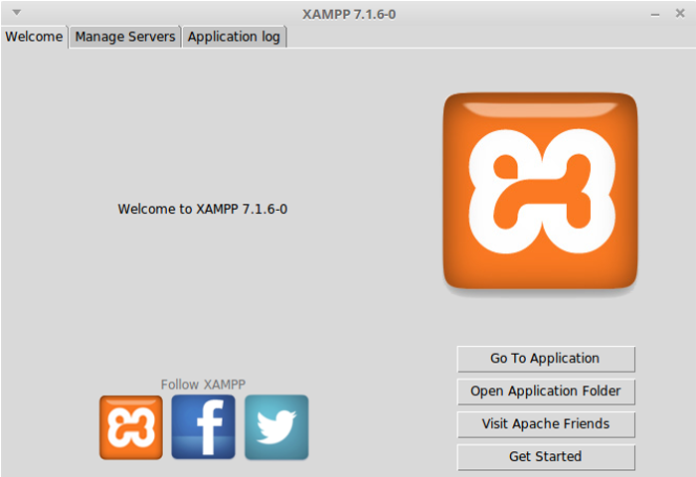
The first thing you’ll need is XAMPP, download the latest version for your operating system. If you clicked either one of those hyper-links and it opened whichever browser opened it will be fine to run our software.

Now that you have XAMPP installed you’re going to want to run the program. It will greet you with a welcome screen. Like this. Its important to notice a few key things.

The Manage Servers tab at the top.
The Open Application Folder button.
If you click ‘Open Application Folder’ it should bring you to a similar directory on your OS to the one below. Locate the htdocs folder, open it, and copy the folder with our latest build into it.
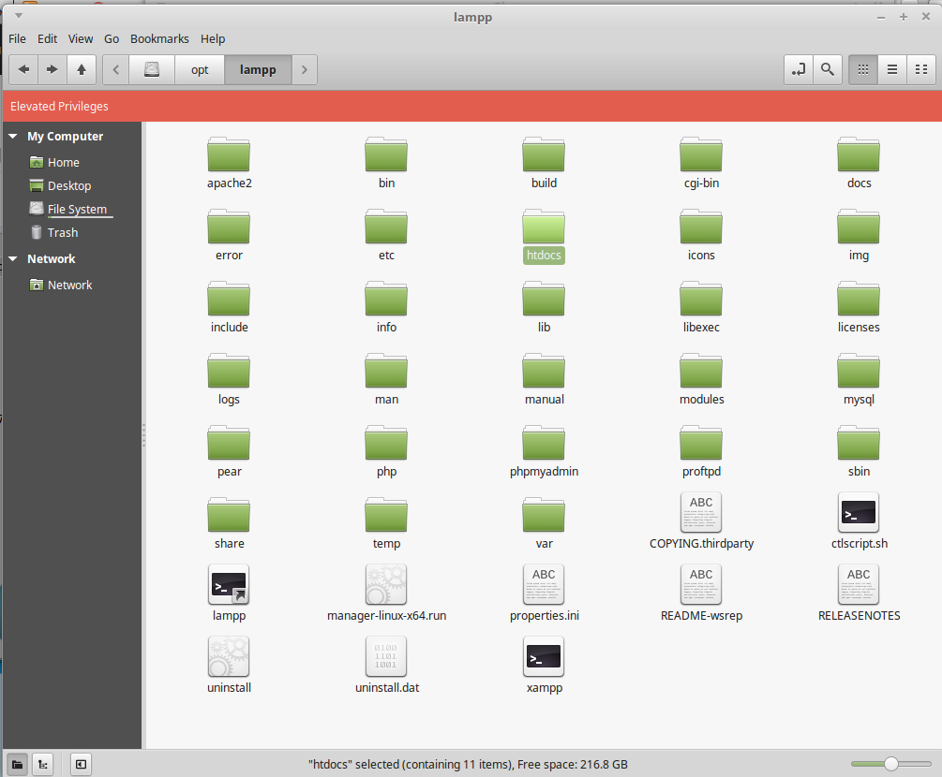
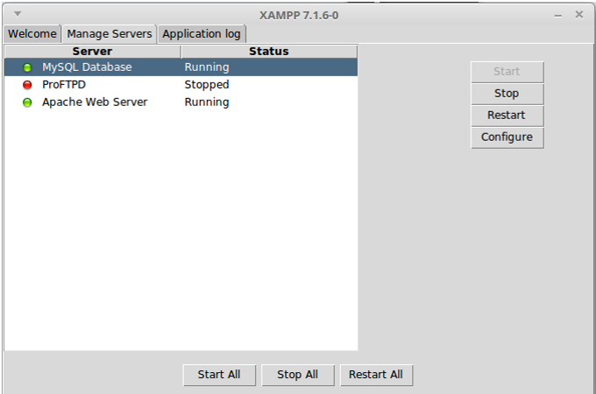
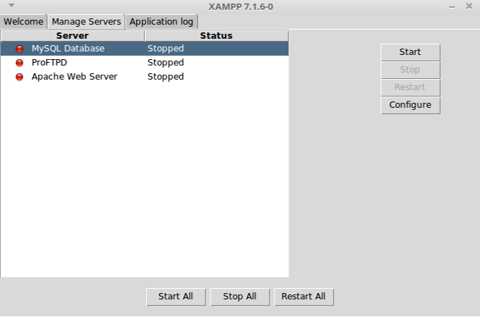
Now that we’ve got our source code in the correct place we can move on to setting up the server for the site. Return to the XAMPP welcome window. Go to the ‘Manage Servers’ tab. Initially all the servers will be stopped. You want to start the MySQL Database and Apache Web Server.

Once they are running open your web browser. Type “localhost” into the URL at the top. It should automatically bring you to a page similar to the one below.
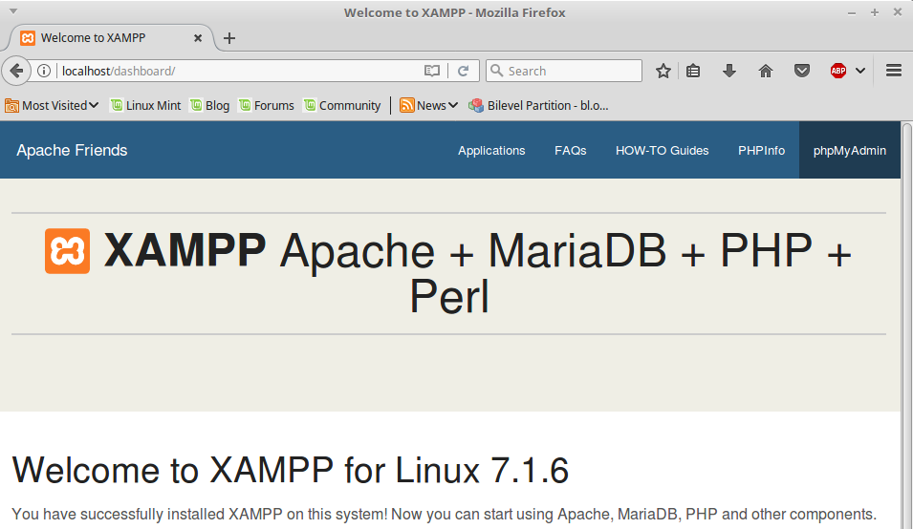
Click the phpMyAdmin button in the top right corner. It will bring you to this page.
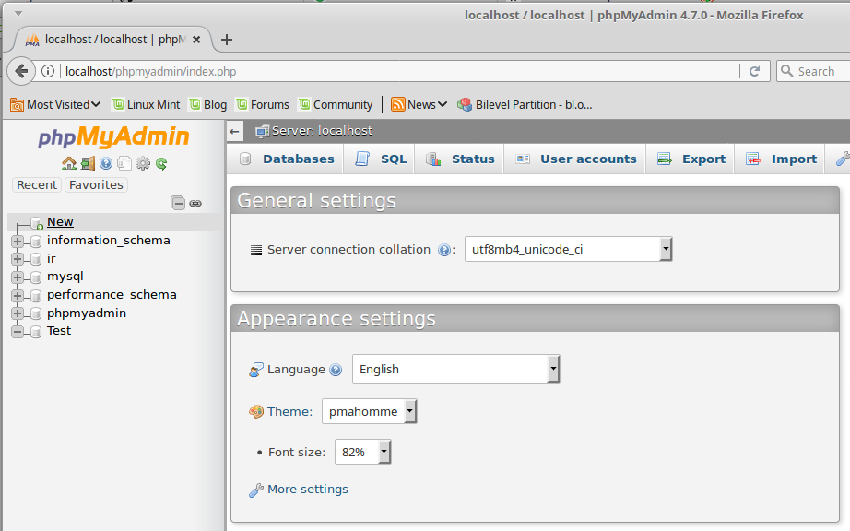
Now we need to create a new database named “ir”, spelling must be exact. In the picture below you see I have already created it. Click “New” above “information_schema” to take you to the next page.

Upon reaching the Databases page type “ir” for the name, select the collation latin1_swedish_ci, and click create.

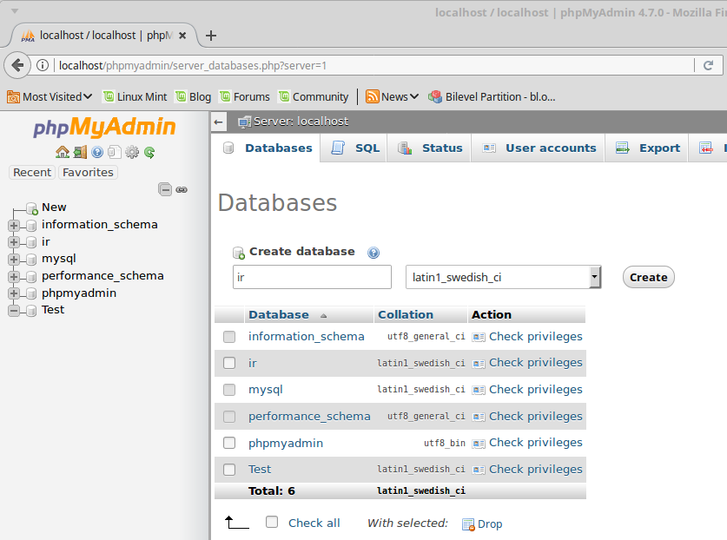

Now that we’ve created the database we can create the tables we need for the server.

Type “users” and choose 7 columns. Then press the Go button in the bottom right.
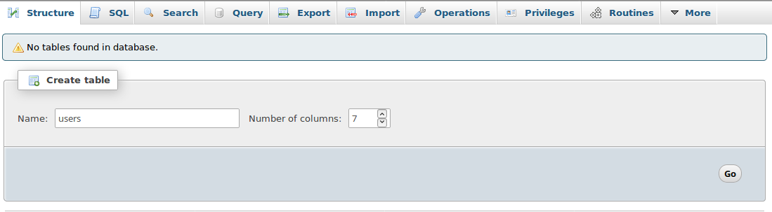

Upon hitting go it will bring you to this table for “users” initially blank you must fill it in exactly as in the picture. Most importantly keep the exact name. For the first named “id” click the check box under ‘A_I’ and click go on the pop-up window to make it Primary auto-incremented.

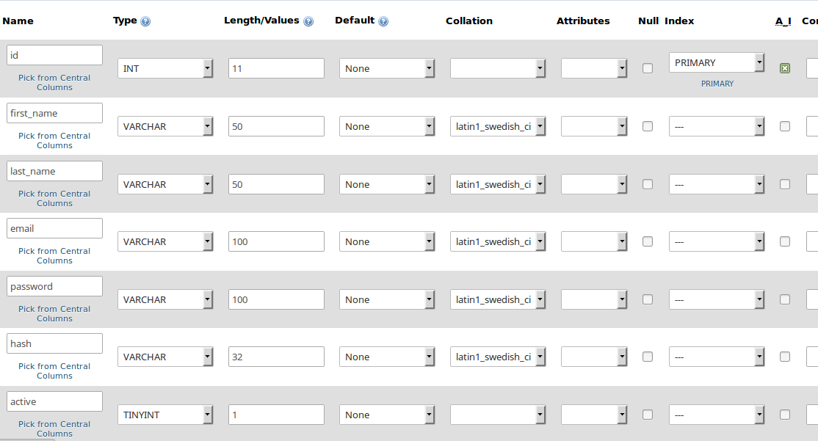
Don’t forget to hit save once you’ve filled in the table completely.

We’re going to setup a second table “budget” with 8 columns as well in the same exact manner.
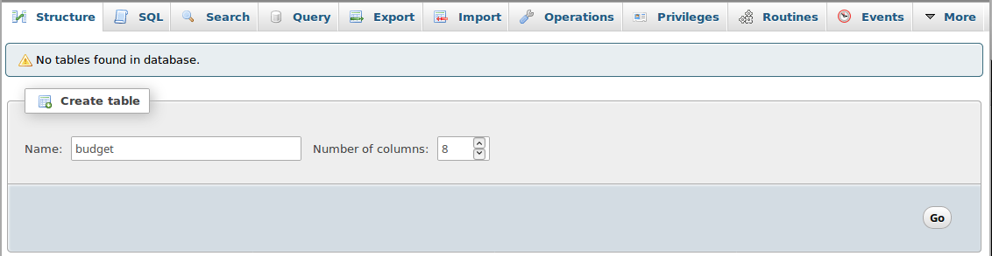

Similarly for “budget” fill in this table exactly. Most importantly keep the exact name. For the first named “id” click the check box under ‘A_I’ and click go on the pop-up window to make it Primary auto-incremented.

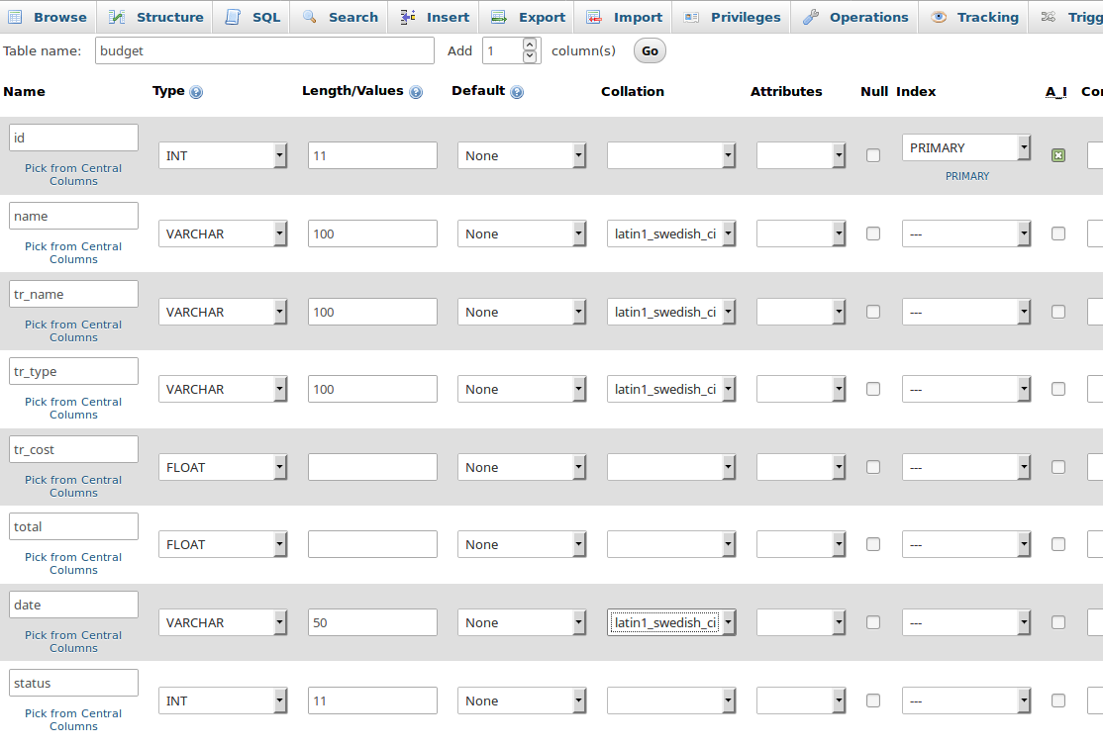
Don’t forget to hit save once you’ve filled in the table completely.

Now that you’ve made the database “ir” and the two tables “users” and “budget” you should see them in the side bar to the left of the screen as so.
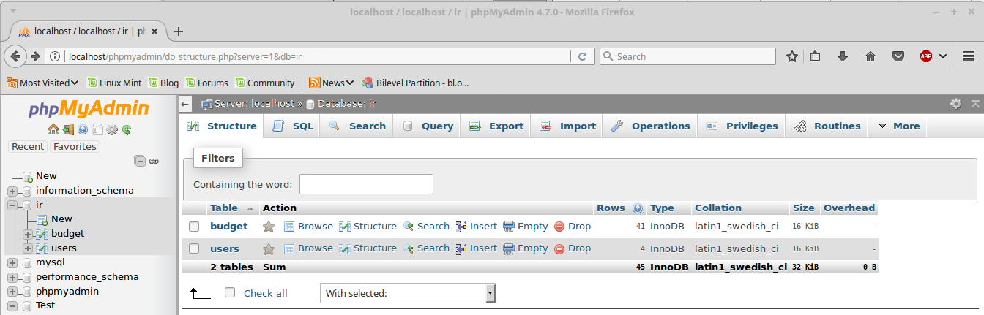
Click into both the tables to confirm they match exactly with the images below.
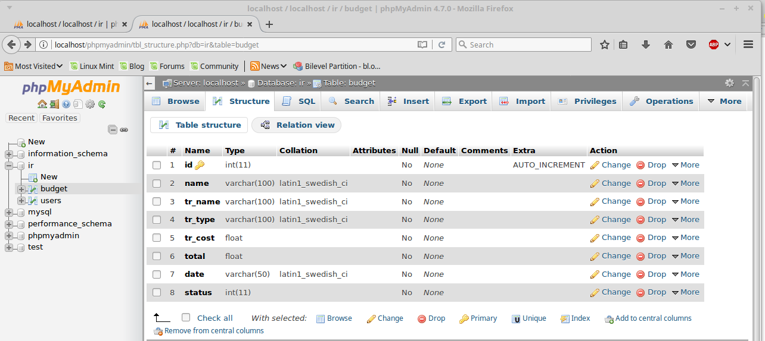
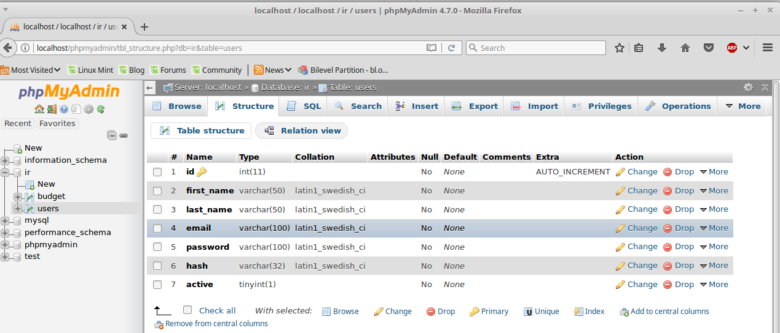
Alright, if you managed to do all of that correctly then everything should work properly.

You can simply open a new tab or go to the URL bar and type: localhost/CurrentRelease
Replacing CurrentRelease with the proper folder name, the one you put in the htdocs folder.

You should automatically be Redirected to the Budget Trace login page.
From here the software is very self explanatory.
Note: If you aren’t in full-screen there is a drop-down menu in the top right corner of the browser.

First Sign Up just as if it were any other website. You can put a fake email if you don’t want to use a real one, but you will not be able to recover your password if you forget it.

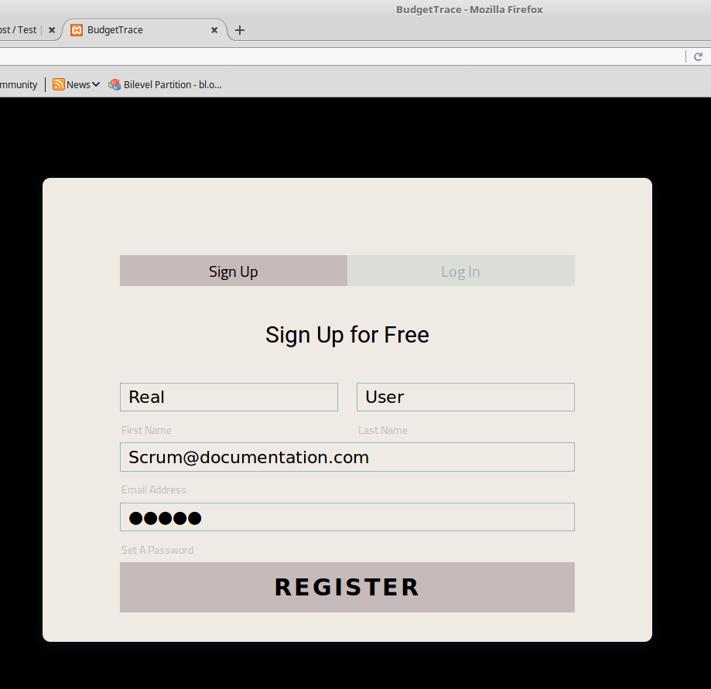

Once you’ve signed up you might have to log back in if it doesn’t do it for you automatically.

Once logged in you should be able to click on BudgetTrace or Home to see the home page displayed as below. Initially it logs you in to your Profile page, which tells you the Name and Email you used.
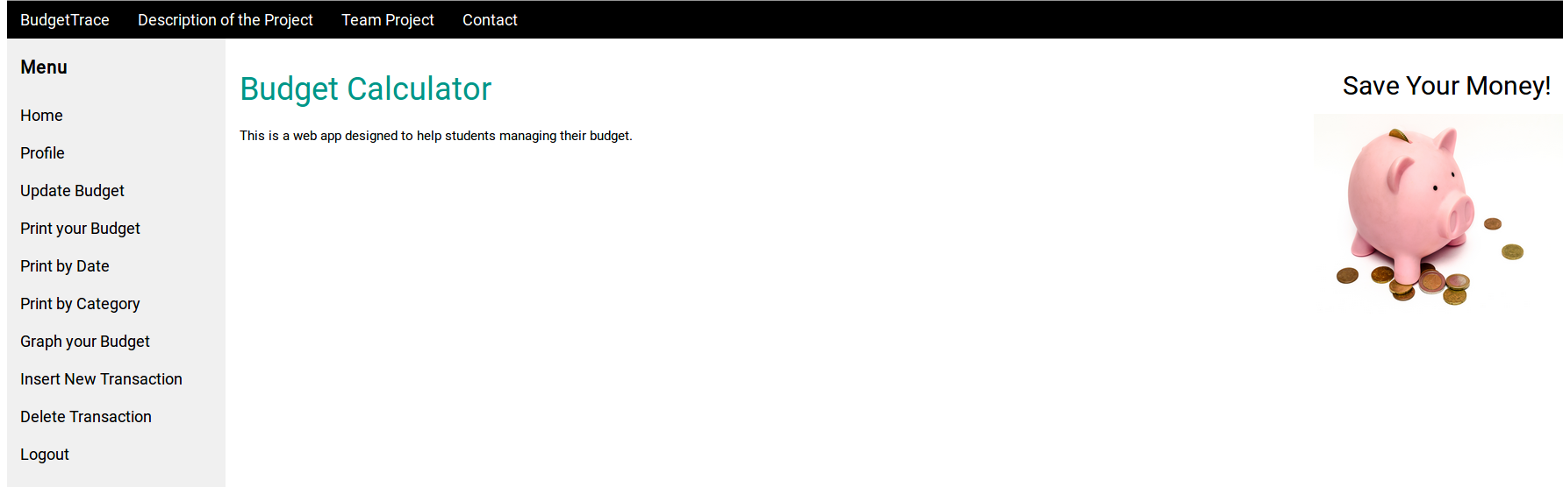

Now you see all the pages you can click on. In order to succesfully plot transactions you must first click on Update Budget.
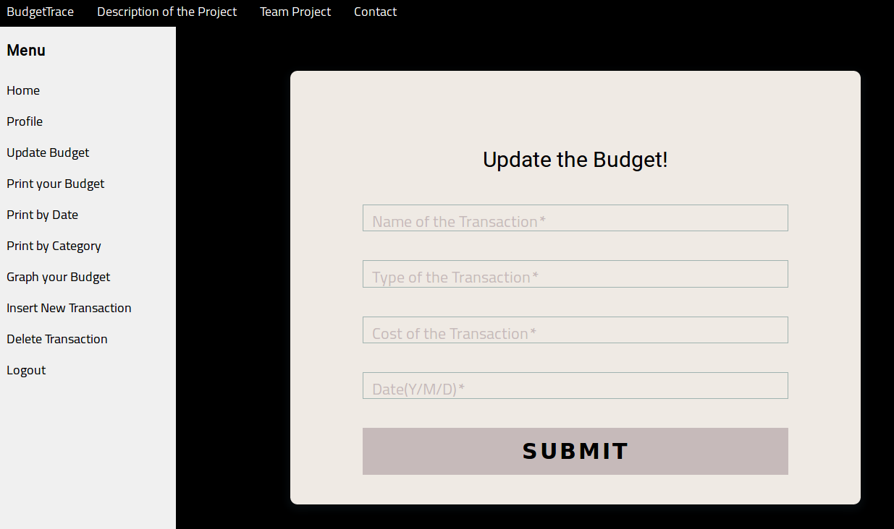

This is our specified transaction format for the table. Both Update Budget and Insert Transaction implement this.

Usually here I put something like: Check, Income, 1000, 2017/07/25.

Its important to think of a good transaction type because the program will group by type in certain functions. For example if you put all your checks in “Income” then when you Print by Category and type “Income” you will be able to see all the checks you deposited and for what ammount. Print by Category works for any Type you input.

Once you have some money in the account you can start recording your transactions.

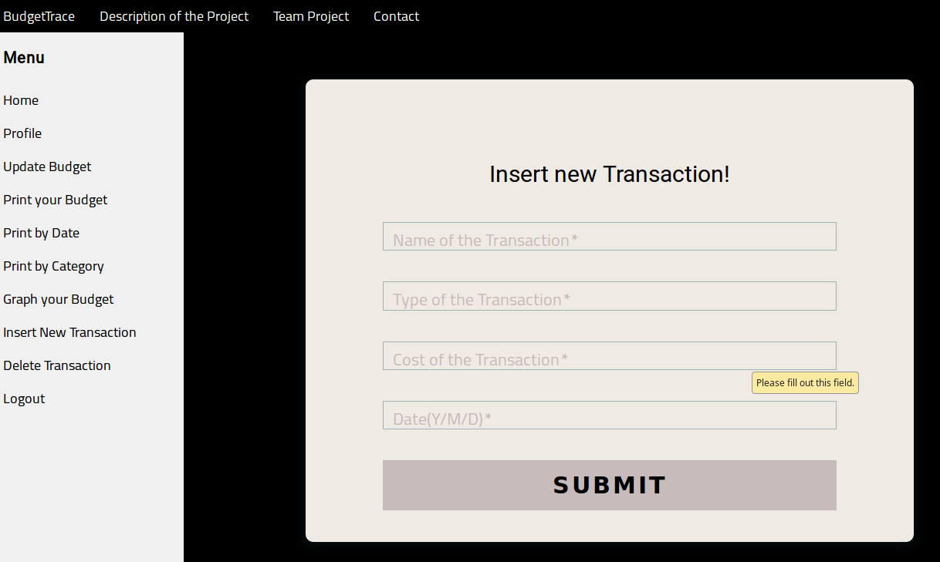

Its also good to know that you can insert any date you want and it will process the data properly. If you have a current transaction history you could potentially enter it and you would be able to see accurate graphs of your spending.

Here maybe you put something like:
Groceries, Food, 50, 2017/07/25
Or maybe
MicroSDCard64GB, Tech, 24, 2017/07/25

You will of course substitute proper dates, I am just specifying the format.

Over time you would accumulate a lot of logged transactions while using this software. Below is some realistic sample data. If you were to use transactions from your bank account this might look almost identical.

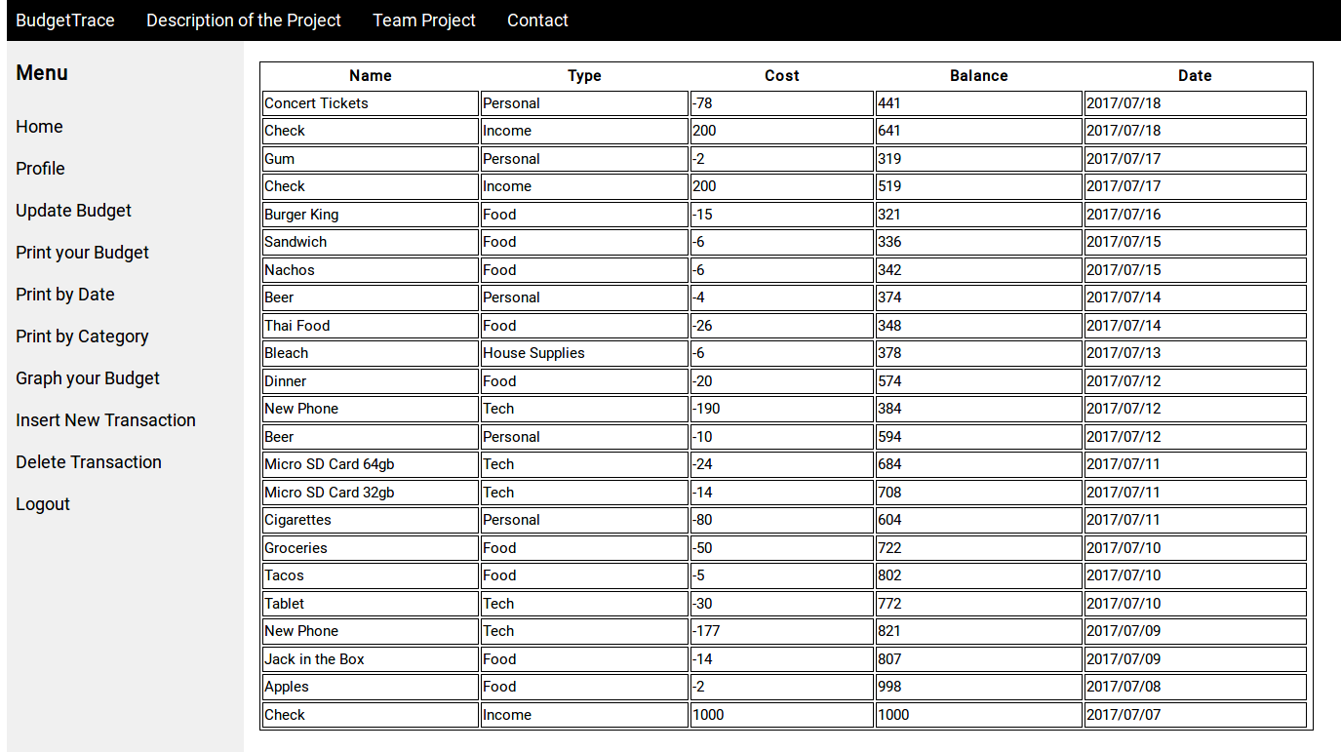
If you have a substantial amount of data sometimes a table is not the best way to analyze how you are spending your money. Sometimes it is a matter of visualizing what you see in a different way. Click on Graph your Budget to see a few different graphs of this transaction data.

Here you can see transaction amount by day. In the application mousing over the data will show you each transactions date, cost, and name.
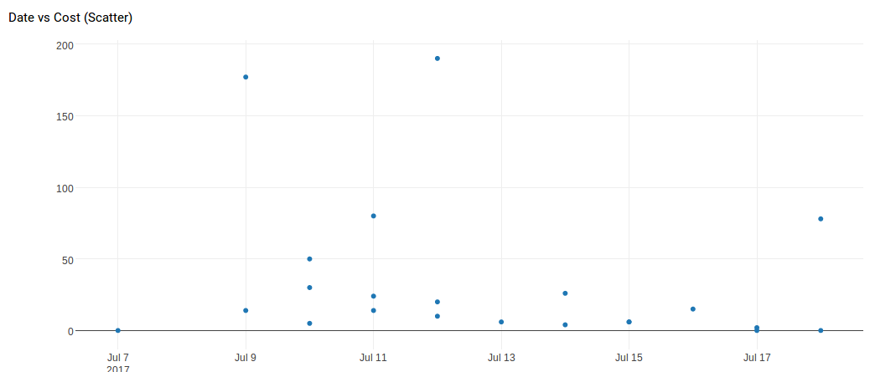
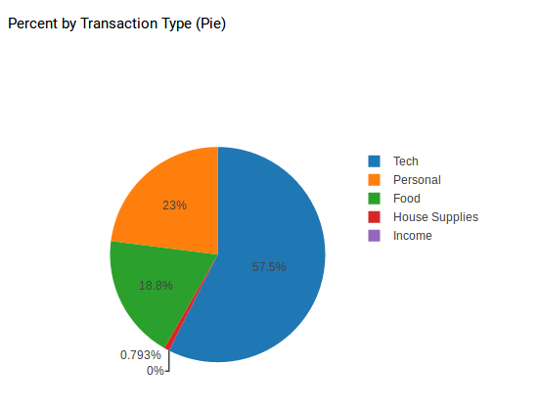
There is also a pie chart that will show you how you spend by type. Of course your “Income” is a positive transaction so it wont total them, but we do display the type because you do have transactions logged.

The bar chart shows transactions stacked by day. Each bar is made up of one or more blocks, each block stacked on top of each other is a transaction.

Lastly we have an area plot of the current budget against your transaction. Each step is iterates to the next transaction. While the line is above the transactions you have a positive budget. If your spending becomes to much the line will dip below the line of transactions.

All of the graphs are interactive, and may have more analytical value to those who use them this way.
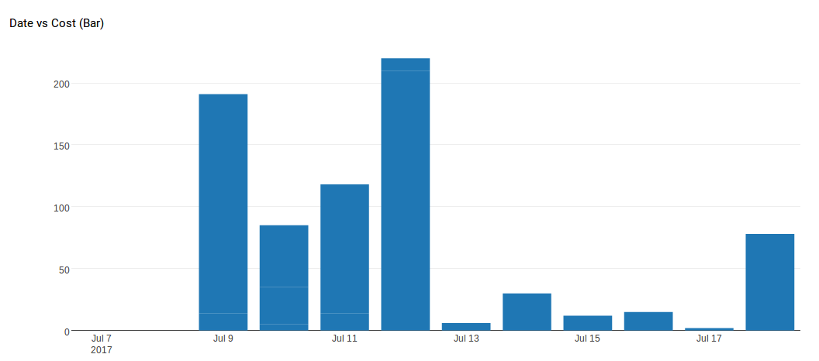
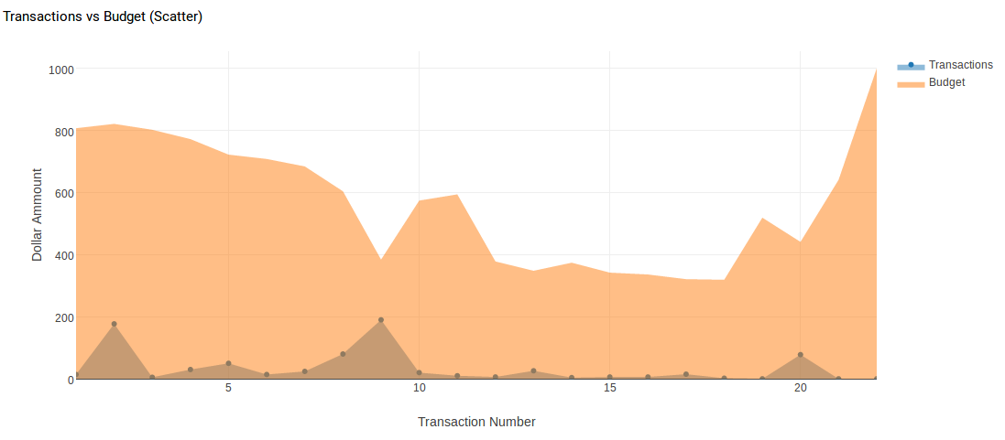
You are now aware of the major functionalities of the software and know how to use it. This is where I will end this user manual, seeing as I have thoroughly explained the process of setting up and using the software.

There is also a delete transaction function that works properly in case you ever enter something wrong.

There is a password recovery function in case you forget your password. When you go to login just click forgot password and you will receive an email with a link to reset your password.

Don’t forget to logout when you’re done using the software and power down XAMPP.

Thank you for using the product from all of us on the Budget Trace team!

